
PUZZLE CRYSTAL
Patented Cognitive STEM Toy
Inventor:
Igor Goldman
US Citizen, Mechanical Engineer, 3D Design Specialist & Inventor
7 US patents (5 in educational toys)
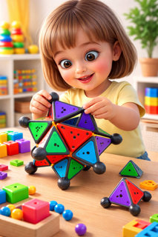
PRODUCT OVERVIEW
Puzzle Crystal is a modular geometric puzzle designed to develop logic, spatial thinking, and fine motor skills.
It is suitable for children, families, seniors, and inclusive tactile learning.
Key Benefits
- STEM & Montessori-inspired learning
- Enhances spatial reasoning and concentration
- Hands-on tactile interaction
- Suitable for multiple age groups
- Inclusive design for visually impaired users
MANUFACTURING ADVANTAGES
- The toy is built from only two different parts
- Configuration: 6 pieces of one type + 12 pieces of the second type
- Only two molds required
- Efficient tooling and simplified production process
- Cost-effective manufacturing
- Simple assembly and packaging
- Scalable for mass production
- Two production options: as a set of parts / as a fully assembled puzzle

MARKET APPLICATIONS
- Children’s educational toy
- Family play and learning
- Cognitive wellness for seniors
- Tactile training for visually impaired
- Corporate branding and promotional use
- Acupressure hand stimulation
PRODUCT FORMATS
- Fully assembled version
- DIY construction set
- “One for me – one for a friend” set
- Sticker packs for toddlers (animals, letters, numbers)
LOOKING FOR PARTNERS
- Manufacturing
- Distribution
- Licensing agreements
CONTACT
Email: igor_goldman1@yahoo.com
Website: https://www.solnishko.info/
QR Code
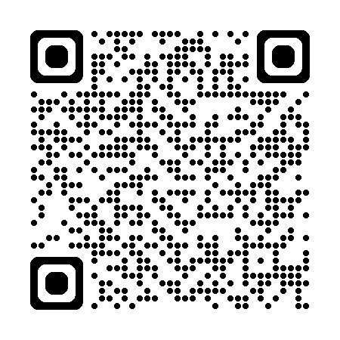

PUZZLE CRYSTAL
专利认知益智 STEM 玩具

发明人：
Igor Goldman
美国公民｜机械工程师｜3D 设计专家｜发明人
拥有 7 项美国专利（其中 5 项为教育/益智玩具专利）
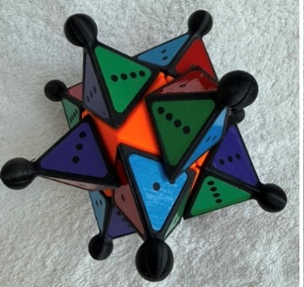
产品概述
Puzzle Crystal 是一款模块化几何拼图玩具，帮助提升逻辑思维、空间想象与精细动作能力。
适用于儿童、家庭共玩、老年认知训练及触觉友好（含视障人群）的学习场景。
核心优势
- STEM 学习与 Montessori 启发式玩法
- 提升空间推理与专注力
- 触觉互动，训练手部精细动作
- 覆盖多年龄段使用场景
- 包容性设计，适配低视力/视障使用者
生产制造优势
- 仅由两种不同零件构成
- 配置：第一种零件 6 件 + 第二种零件 12 件
- 仅需两套模具
- 工装效率高，生产流程简化
- 制造成本更可控
- 组装与包装简单
- 适合规模化量产
- 两种出厂形式：零件套装（DIY）/ 组装成品拼图

应用市场
- 儿童教育益智玩具
- 亲子家庭共玩与学习
- 老年认知健康训练
- 视障/低视力触觉训练
- 企业品牌定制与礼品促销
- 手部按压刺激（acupressure）辅助使用
产品形态
- 成品组装版
- DIY 零件拼装套装
- “一份自用 + 一份送朋友”组合装
- 幼儿贴纸扩展包（动物 / 字母 / 数字）
合作需求
- 生产制造合作（OEM/ODM）
- 区域分销合作
- 授权与许可合作（Licensing）
联系方式
邮箱：igor_goldman1@yahoo.com
网站：https://www.Solnishko.info
维码: QR Code

